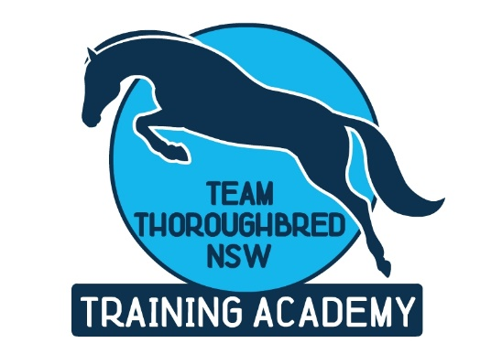

Team Thoroughbred NSW Training Academy Courses FAQ

Fee Free Traineeships
Traineeships are a proven pathway to well-paid jobs in a diverse range of careers, including the Racing Industry.
There’s never been a better time to start a traineeship in NSW!
The NSW Government is paying the course cost for 70,000 new traineeships – meaning trainees undertaking a government funded traineeship course no longer face a student fee of up to $1,000.
Traineeships are a great career pathway. They combine on-the-job training with formal study to give you the skills and experience employers are looking for. Traineeships generally take around 1-2 years to complete, and trainees earn a salary while they learn.

What is a traineeship?
A traineeship is a job that combines work and training – you earn as you learn. It is a work based training program, which combines on-the-job training and off-the-job study. Trainees are paid the National Training Wage, which is about 80% of the award wage. You may be eligible for a living away from home allowance.

How do you do the training?
Training is a combination of on-the-job (work) and off-the-job (study). On-the-job training is conducted by your employer in the workplace. Off-the-job training may be delivered by Team Thoroughbred NSW Training Academy.
Otherwise, you can complete special training packages at home. These are then submitted for assessment. Traineeships are usually conducted over a period of 12 months.

Why is Racing NSW endorsing traineeships?
Training of industry workers is essential for ongoing success of the racing industry both nationally and internationally. Government funded traineeships assist with the large costs involved in training and allow, through the nationally recognised Training Package, a viable means of ensuring an ongoing supply of track riders, apprentice jockeys and other industry workers.
Every industry in Australia is required to ensure that people who work in the industry have a nationally recognised qualification

Do you fit the bill?
You can be aged from 15 years. You need to be reasonably fit and healthy. The job is quite physically demanding. Many jobs with horses require early morning starts and often split shifts.

Where do you do the training?
Presently, training is conducted both on the job and off the job. Centres used for delivery are at Metropolitan racecourses and; Hawkesbury, Tamworth, Grafton, Port Macquarie, Dubbo, Canberra and Wagga racecourses by highly qualified instructors and experts from the racing industry.

What are the opportunities?
On completion of the traineeship, you will be able to work in a capacity such as a stablehand or track rider, or jockey. You will be able to handle and care for horses in commercial horse racing enterprises.
Talented track riders and jockeys are in great demand nationally and internationally.

What is the National Racing Industry Training Package?
The National Racing Industry Training Package was developed to ensure uniformity in racing training.
The main aims of the Training Package include:
- Training for qualifications that are nationally recognised
- Defining the training stages or levels
- Defining specific knowledge and skills (competencies) that are required by the racing industry
- Setting standards for assessing those skills and knowledge

What do students learn in the track rider and jockey course?
Students have tuition with a range of industry recognised experts. Racing NSW have endorsed a number of respected jockeys and former jockeys to deliver training throughout the State
Off-the job training also consists of studies in health and safety, personal fitness and a balanced diet, and financial management
Students learn to work in a team environment and to accept responsibility
Much of the training is completed on-the-job with the horse trainer.

